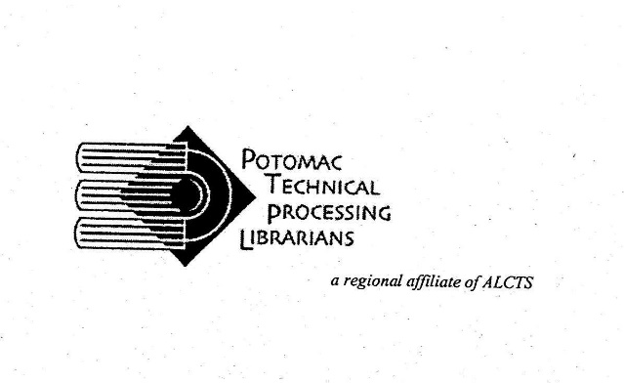
LINKED DATA: WHERE ARE WE NOW?
Friday, October 14, 2022
10:00am-4:00pm
Carnegie Endowment for International Peace
1779 Massachusetts Ave. NW
Washington, D.C. 20036

Report of the Treasurer
October 2021 – October 2022

Checking Account Balance Oct. 2021 $ 13,661.76
Checking Account Balance Oct. 2022 $ 15,183.34

2021 ANNUAL MEETING FIGURES

MAIL REGISTRATIONS

1 @ 35.00 $ 35.00
PAYPAL REGISTRATIONS

47 @ 33.68 $ 1,582.96
3 @ 33.20 $ 99.60

TOTAL 1,717.56

EXPENSES

Learning Times predictive service, 100 active registrations $ 5,233,00
Learning Times webservice, closed caption 100 more reg. $ 2,743,50

TOTAL EXPENSES $ 7,976.50
TOTAL REGISTRATIONS $ 1,717.56

DIFFERENCE $ 11,924.44

OTHER 2021 EXPENSES

3 Scholarships @ $2,000.00 $ 6,000.00

Wild Apricot (ISP provider) $ 1,166.40

Learning Times prepayment for 2021 Annual Meeting $ 5,666.00

Respectfully Submitted: Linda L. Wirth, PTPL Treasurer

